New Economy Network Australia
Draft NENA Operational Handbook

Prepared by NENA Steering Group
For Discussion
3 September 2018
nena@neweconomy.org.au

Contents
INTRODUCTION 4
OUR PRINCIPLES FOR WORKING TOGETHER 4
Handling power – supporting distributed governance and shared decision making power 4
Our norms and boundaries 4
What we owe to each other: respect, sharing, compassion, patience 4
How we’ll handle conflict 5
HOW WE’LL WORK 6
Overview 6
Volunteers supporting NENA’s administrative and coordinating functions 9
Communicating together, within the NENA network 9
NENA Communication Objectives 9
Supporting members to engage in NENA communication pathways 9
Face to face meetings 10
Technology for virtual meetings 10
Communicating about NENA to the outside world 11
Shared resources to promote NENA 11
External communication strategies 11
ATTACHMENT 1 – MEMBERSHIP POLICY 12
Criteria for Membership 12
Membership Benefits 12
Cost of Membership – 2018-2020 13
Rights and Responsibilities of Membership 13
Denial or Termination of Membership 13
ATTACHMENT 2 – NENA CODE OF CONDUCT 14
NENA’s WORKING VALUES (culture) 14
NENA CODE OF CONDUCT 14
ATTACHMENT 3 – CHARTER FOR NENA HUBS 17
About NENA Hubs 17
Process for setting up a new NENA Hub 17
Charter for NENA Hubs 19

New Economy Network Australia (NENA)
NENA Operational Handbook

INTRODUCTION

The NENA Operational Handbook aims to set out how the people and groups within NENA will work together, and this document will be updated as required.

OUR PRINCIPLES FOR WORKING TOGETHER

Handling power – supporting distributed governance and shared decision making power
The people who make up NENA believe that distributed governance is important for growing a network. At all opportunities, it’s important to acknowledge how power structures are working, and how best to share opportunities for sharing decision making power.
NENA’s Operational Structure and Legal Constitution has been drafted to find a balance between meeting the legal requirements for a cooperative under Australian law, while also setting up operational structures that allow freedom, autonomy and healthy communication between elements of NENA such as geographically and sectorally based Hubs.
NENA has a Board of Directors responsible for the healthy functioning of the organisation, a Strategy Directions Group responsible for setting the national and regional strategic objectives of the network and a Participatory Budget Group responsible for raising and allocating funding for the network.

Our norms and boundaries

What we owe to each other: respect, sharing, compassion, patience
The fundamental principles of NENA are set out in the NENA Constitution.
The following key ‘cultures’ will be driving NENA’s development
- Free flowing information
- Individual autonomy
- Opportunity for All
- An atmosphere of trust and respect
- All share a stake in the outcome.
Success in all of these areas will be based on “getting people informed and keeping them informed”. Information sharing up, down and across the organization will be required to achieve this success and to foster a sense of ‘ownership’ by the members of NENA. To do this will require a communications strategy to be approved by the NENA Board and Strategy Group.

How we’ll handle conflict
The people building NENA acknowledge that differences of opinion and conflict are a normal part of human interactions and work life. All efforts will be made to maintain peaceful and stable working relationships among members, but where conflict arises, the Code of Conduct and Constitution will assist with conflict resolution.
Attachment 2 sets out the draft NENA Code of Conduct.

HOW WE’LL WORK

Overview
NENA’s goal is to be a network in which individuals and organisations can find each other, find out about each other’s work and work effectively together to build the new economy.
There are four key elements to NENA’s structure:
- MEMBERS. Our structure starts with NENA Members. Individuals and Organisations can be members of NENA. The draft NENA Membership Policy is at Attachment 1.
- NENA HUBS. NENA Members can create or join ‘Hubs’, which carry out much of NENA’s work. The hubs can be created based on geography (towns or regions) and also by sector (eg education, technology), in order to build networks, create collective support and create collective activities.
- BOARD OF DIRECTORS. All NENA members can elect the Board of Directors. The Board of Directors is responsible for the healthy functioning of the network, including good governance, legal compliance and business management.
- STRATEGY AND FINANCE. In addition to being able to work independently in semi-autonomous hubs, and elect the Board of Directors, NENA members can elect TWO other collective decision making bodies within the NENA Structure: (i) a Strategy Group, to help create the national strategic objectives and priorities of the network and (ii) a Participatory Budget Group which will enable people across the network to contribute to the raising and allocation of funding for the network, and advise the Board of Directors.
NENA’s Operational Structure and Legal Constitution has been drafted to find a balance between meeting the legal requirements for a cooperative under Australian law, while also setting up operational structures that minimise hierarchy, and allow freedom, autonomy and healthy communication between elements of NENA such as geographically and sectorally based Hubs.

Diagram 1 – The overall structure of the Network
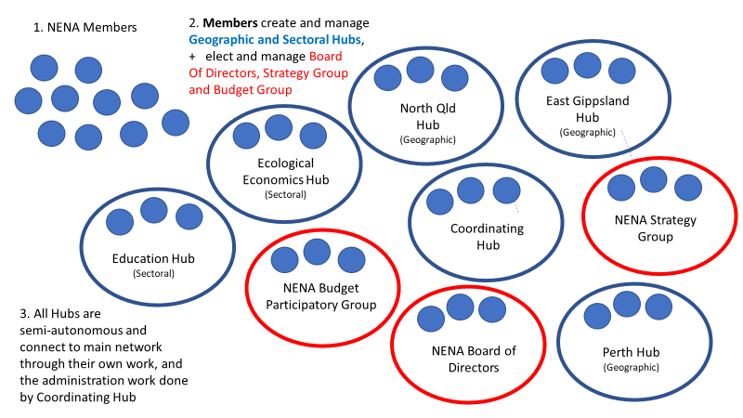
Diagram 2 – How the Network will build its Core Strategies: the Strategy Group
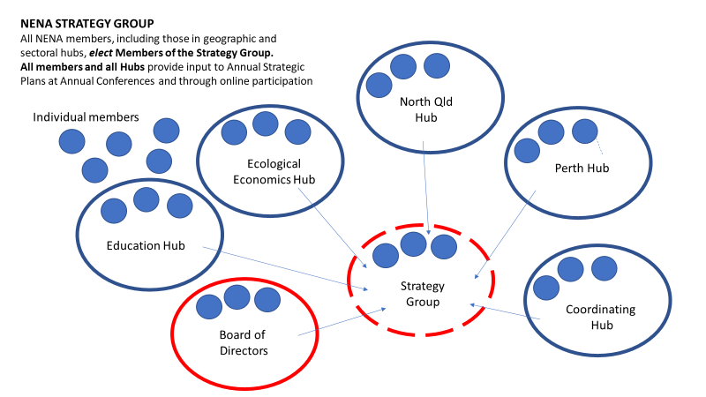

Diagram 3 – How the Network will determine financial structures and priorities: the Budget Participatory Group
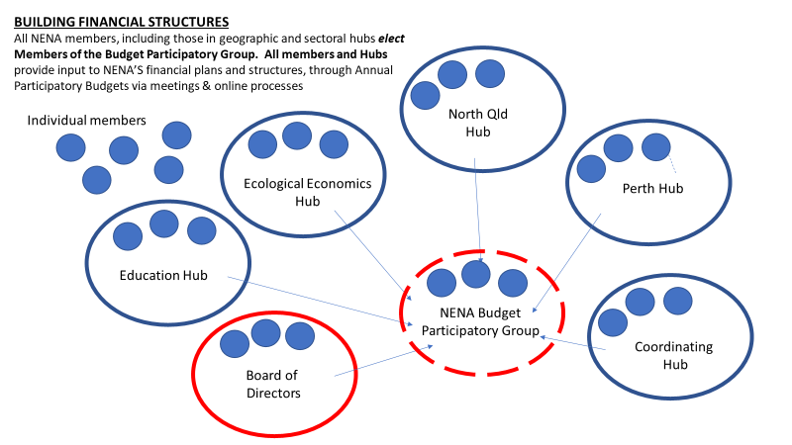

Diagram 4 – How the Network will ensure good governance, legal compliance and business management
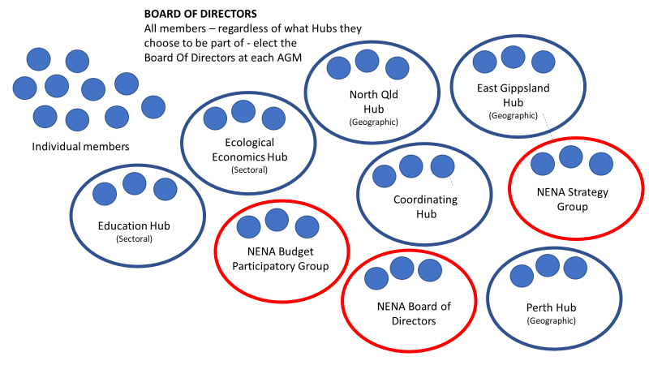

Volunteers supporting NENA’s administrative and coordinating functions

Until funding is obtained for paid staff, volunteers are managing all aspects of NENA’s work. Volunteers have offered to manage the NENA Coordinating Hub. The Coordinating Hub will provide the following support:
- Coordination support, including answering emails and linking people to existing hubs or helping them create their own new hubs
- Social media, website and other internal communication support for members
- Social media, website, communication and coordination support to the NENA Hubs
- Assistance and support for NENA Hubs hosting conferences, symposia and other events
- Secretariat support for the NENA Board of Management, NENA Strategy Group and NENA Participatory Budget Group

Communicating together, within the NENA network

Communicating effectively between all elements of the network is critical for the long term success of NENA.

NENA Communication Objectives
- To make communication networks work across the organization.
- To ensure that all information is communicated/transferred
- Operational processes
- Current issues and priorities
- Future plans and strategies
- Financial information
- To identify ‘best uses’ for the various forms of communication technologies/platforms available so that they will be effective in/at the various ‘work situations/levels’ of NENA.
- To transfer to people the information that they need to rapidly and successfully participate in achieving local objectives - preferably via peer-to-peer networks/platforms.
- For organization-wide objectives, to assess and plan effective ‘messaging’ when ‘up, down, and across’ members are all present (eg: at annual meetings)
- To frame all messages with the intent to create an open and responsive communication environment

Supporting members to engage in NENA communication pathways

The ‘membership invitation pack’ will contain:

- Acceptance form and signing up to NENA membership policy.
- Acknowledgement of personal responsibility in becoming informed - and keeping informed - of NENA’s activities through joining NENA’s general/public communications channels (eg: facebook, twitter etc).
- Directions on how and where to participate in Hub work via the NENA web-site and local platforms and that education on particular aspects of NENA’s work is very much self-paced, self-directed and DIY
- Key, relevant contact points/help-desks for questions and answers and peer-to-peer work at the local level.

Face to face meetings
NENA’s members will aim to meet in person as often as possible, including through
- Annual Conferences
- Regional events and gatherings
- Social nights, film nights and Retreats

Technology for virtual meetings
NENA’s zoom account will be used for
- Monthly webinars for the network, hosted by the Coordinating Team
- Regular meetings of NENA Hubs, as requested by the Hubs
- Regular meetings for the Council, Board and Participatory Budget Group

Communicating about NENA to the outside world

Shared resources to promote NENA

NENA members are invited to work together, either through the NENA Coordinating Hub or a different Hub, to ensure up to date materials are available for all members to communicate about NENA to outside networks, including: powerpoint presentations, posters, flyers and other written and video material.

External communication strategies
NENA will seek an experienced volunteer to act as a “communications/social media” expert to ensure sound and timely communications of all relevant material across the organization, and to be the ‘connector’ for material/reports to be circulated throughout the network.

ATTACHMENT 1 – MEMBERSHIP POLICY

NENA is a growing network of individuals and organisations working to transform Australia’s economic system. We are working towards ensuring ecological health and social justice are the foundational principles and primary objectives of the economic system. By becoming member of NENA yourself, or with your organisation, you will be actively contributing to progressing NENA’s vision and making tangible the new economy, one premised on the wellbeing of planet and people.

Criteria for Membership
NENA membership is open to individuals and organisations in Australia who share, and agree to, NENA’s mission, principles and objectives, are willing to adhere to membership policies, and consent to be publicly listed as NENA members.

Membership Benefits
- Have your organisation or community listed on our directory and national map. As a member of NENA you, or your organisation or initiative will be listed on our website – an easy to find and navigate directory of all the activities and organisations supporting momentum towards the new economy.
- Discounted tickets for our annual conference (from 2019 onwards). NENA’s conference is one of Australia’s largest gatherings of a broad sector of organisations working towards a fairer and more ecologically restorative economy. Join us to share stories of success, address challenges and unite with the broader movement.
- Connection, learning and networking with peers involved in similar essential work in the new economy. As a member this can be done through a NENA hub, event or webinar.
- The ability to join or start a hub. Hubs are sectoral or locality-based clusters of organisations and/or individuals working on specific topics, themes or initiatives within the network. They serve to connect, deepen learning and development opportunities and identify common issues across the sector. They can also be used to establish a community platform for a region that is seeking to grow and strengthen their local economy. These hubs converse and
- interact with NENA’s Strategy Group, and feed into deciding and advancing the overarching objectives of the network.
- Ability and resources to organise and host a NENA event. Create a conversation in your community about issues challenging our economic and planetary well-being. Membership will allow you to host people under the NENA banner, though a film night, symposium or community forum, to have meaningful discussions about key issues in the network. It will also grant you access to a communications pack, with NENA logos, PowerPoint presentations and key talking points.
- Vote for office holders or stand for elections yourself for NENA’s Board, Strategy Group and Budget Group. NENA aims to be as participatory as possible in its governance structure, allowing for a range of ways to be involved.
- Connect to international networks and organisations, such as RIPESS and the Wellbeing Economy Alliance.
- Be invited to contribute to NENA-wide submissions to government on matters relevant to NENA’s guiding objectives.

Membership fees are offered on sliding scale from individual to organisations dependent on total income. Please see details below.

Cost of Membership – 2018-2020
- Individual membership – $30
- Organisational membership – sliding scale based on annual net income:
Organisation income | NENA annual membership fee
0-$5,000 | $50 per year
$5,000-$20,000 | $100 per year
$20,000 - $50,000 | $150 per year
$50,000 - $200,000 | $300 per year
Over $200,000 per year | $500 per year

Rights and Responsibilities of Membership
Please see the NENA Constitution for more details, but in summary:
Each NENA member is entitled one vote for the NENA Board of Directors, one vote for members of the NENA Strategy Group and one vote for the NENA Participatory Budget Group.
Members are invited to consider joining NENA Hubs, and creating or joining existing NENA Chapters in towns, cities and communities.

Denial or Termination of Membership
The NENA Constitution sets out all provisions relating to the acceptance and termination of members.
Membership can be terminated if a member breaches the Code of Conduct.
Conflict management and resolution processes are set out in NENA’s Constitution.

ATTACHMENT 2 – NENA CODE OF CONDUCT

The mission of NENA is to serve as an alliance of individuals and organisations that work together to positively transform Australia’s economic system so that achieving ecological health and social justice are the foundational principles and primary objectives of the economic system.

NENA’s WORKING VALUES (culture)

What we owe to each other: respect, sharing, compassion, patience
As an organisation based on a co-operative governance structure, NENA seeks to foster the following key cultures:
    - Free flowing information
    - Individual autonomy
    - Opportunity for All
    - An atmosphere of trust and respect
    - All share a stake in the outcome.

NENA CODE OF CONDUCT

The following behaviours are expected of all NENA members with respect to their involvement and representation of the Network:

    - A commitment to principles, purpose and mission of the Network.
    - Loyalty to the Network, its community, and all other stakeholders.
    - Treat other members of NENA and the public, with courtesy, respect, kindness and compassion at all times.
    - Honesty and trustworthiness.
    - Positive, assertive, open, careful and respectful communication.
    - Where possible, providing positive comments before any negative ones.
    - Listening thoughtfully to feedback including when it is negative.
    - Only engaging in humour that is acceptable to all present.
    - Offering an immediate and sincere apology for any offence and giving an undertaking not to repeat the behaviour.
    - Respect for, and attention to, the safety and wellbeing of other NENA members, and members of the public with whom they come in contact through their endeavours.
    - Maintaining high quality professional inter-personal relationships and appropriate relationship boundaries with all Network stakeholders, community members, colleagues and co-creators.
    - Compliance with all policies and procedures of the Network, and any legislation or regulatory framework relevant to their involvement in the organisation.
    - A positive pro-active attitude to their contribution to the mission of NENA and the working relationships involved.
    - Willingness to learn, share, collaborate and to do so with respect and compassion for others.
    - Lawful behaviour at all times whilst involved with and representing NENA.

BEHAVIOURS THAT ARE UNACCEPTABLE
The following behaviours are unacceptable and go against the respectful, sharing and compassionate ethos NENA stands for. Therefore, the enacting of any of the below will result in the expulsion of a member from the Network.

- Any action or communication as a member, contrary to the stated mission, principles and policies of NENA.
- Serious or repeated failure to discharge their obligations to the co-operative under these rules, the NENA Code of Conduct or any contract or memorandum of understanding entered into by the member with the co-operative;
- Acting in a way that has:
    - prevented or hindered the co-operative in carrying out one or more of its primary activities, or
    - brought the co-operative into disrepute, or
    - been contrary to one or more of the co-operative principles and has caused the co-operative harm either by omission or commission.
- Any behaviour which could constitute:

  - Sexual harassment.
  - Bullying, including emotional or physical abuse, whether by commission or omission of an action or communication.
  - Negative discrimination (including communications or actions, or failure to include a person in activities or communication) on the basis of gender, age, sexuality, race, culture, religious or political beliefs, physical disability, or HIV status.

- Any intentional misuse or misappropriation of, the funds, equipment or technology of NENA.

MEMBER ACKNOWLEDGEMENT

I have read and understood the Organisational Guiding Principles, Purpose, Mission and Member Code of Conduct

By becoming a paid member of NENA, I understand that the NENA Code of Conduct is binding on me with respect to my involvement with NENA.

ATTACHMENT 3 – CHARTER FOR NENA HUBS

About NENA Hubs
The New Economy Network Australia (NENA) works to facilitate connections, showcase and promote innovative projects, build peer-to-peer learning and use collective strategies to advocate for change, so that we can build a strong movement of people demanding, creating and benefiting from a ‘new’ economy. There are three dimensions to NENA’s work: we are building networks, connections and shared initiatives:
- within specific geographic areas such as towns/cities, regions and states;
- across different sectors within the new economy, including: sustainable food, energy, transport, housing, indigenous economics, ecological economics and many more; and
- that prioritise specific strategic goals every year
To facilitate the work of the Network, and keep NENA’s structure as open, accessible and non-hierarchical as possible, NENA is made up of interconnected and semi-autonomous hubs. NENA has a central coordinating hub, and a growing number of connected, semi-autonomous sectoral and geographic hubs that bring people together, manage events, networking opportunities and new economy initiatives. NENA has a Board of Directors responsible for the healthy functioning of the organisation, a Strategy Group responsible for setting the national and regional strategic objectives of the network and a Participatory Budget Group responsible for raising and allocating funding for the network.
NENA’s Operational Structure and Legal Constitution has been drafted to find a balance between meeting the legal requirements for a cooperative under Australian law, while also setting up operational structures that allow freedom, autonomy and healthy communication between elements of NENA such as geographically and sectorally based Hubs.
NENA is made up of volunteers from organisations around Australia, who are committed to building the New Economy Network Australia. Everyone works together, to manage different aspects of NENA’s work. For more information about NENA Hubs visit: www.neweconomy.org.au

Process for setting up a new NENA Hub

When two or more people would like to create a new NENA Hub, they can contact the NENA Coordinating Hub to discuss their intentions and request the NENA Hub documents, including the NENA Charter and NENA Code of Conduct.
Once the proposed Hub members have created the new Charter, they can send it to the NENA Coordinating Hub and the Coordinating Hub will check that the goals of the Hub meet the goals of NENA, and identify if there’s any cross over, connections or duplication with other Hubs. The default position is that the NENA Hub will be allowed to form and operate, unless the Hub contradicts the objectives and fundamental principles of NENA and/or directly overlaps with an existing Hub. If a Hub already exists that has the same aims of the proposed Hub, the NENA Coordinating Hub will work with the new group to help them discuss their next steps, including the option of joining an existing hub or expanding an existing hub so they can be part of it.

Charter for NENA Hubs
1. Hub Principles
When working together in a NENA Hub, and when speaking on behalf of NENA or representing NENA at events, Hub members will:
- Adhere to the Mission and Objectives of NENA as set out in the NENA Constitution
- Comply with the NENA Code of Conduct and actively promote a healthy communication culture
- Use the NENA Code of Conduct for dispute and conflict resolution
- Comply with the meeting rules and other rules created under this Charter, for this Hub
- Be non-political – that is, NENA Hub members will not represent the views or opinions of any political groups
2. Membership of a Hub
- Membership of a NENA Hub is open to anyone who:
  - endorses the principles and objectives of NENA
  - becomes a paid member of NENA
  - agrees to the NENA Code of Conduct
  - agrees to the specific Charter of the Hub they wish to join
- People can become a member of the Hub by contacting the coordinators of the Hub and asking to join. All new members will be invited to agree to the principles of the Hub.
3. Administration of the Hub
Hub coordinators will keep a list of all members, including names and email addresses, and ensure that all members of the Hub have access to a current list of other members.
Hub coordinators may set up email lists, private facebook groups and other ways for the Hub members to stay in touch with each other.
Hub coordinators will provide member lists to the NENA Board of Directors and Coordinating Hub, to ensure all members of the Hub are connected to NENA news and updates.
Hub coordinators will ensure that the Hub provides updates to the NENA membership about their work, through any or all of the following: posting on NENA’s facebook page and group page; organising and providing information through a NENA Webinar; updating their Hub webpage and participating in Annual Conferences and Strategy Meetings.
4. Fundraising and financial issues
As an unincorporated entity, the NENA Hub will not have its own bank account, but can work with the NENA Participatory Budget Group to have any fundraising or financial matters auspiced by NENA, including having money raised for events via NENA booking systems and managed in the NENA Bank Account
The NENA Coordinating Hub can set up event booking systems that can receive funds and which can be used by the Hub to pay for their own costs associated with any events run under the NENA Banner.
5. Meeting Rules
Members of the Hub will aim to meet several times each year, either in person or via the internet (eg zoom).
The standard meeting rules from the NENA Constitution apply to Hub Meetings unless otherwise agreed by members of the Hub.
6.Cessation of the Hub
The NENA Hub can be closed down or made dormant at any time, when a majority of existing members pass a resolution and agree to do so.

FORM TO BE FILLED OUT TO CREATE NENA HUBS

Name of Hub:
Founding members:
Principal coordinating contacts for the Hub:
Email addresses of coordinating contacts:
Objectives of the Hub: (to be created by founding members of the hub; objectives can be changed through a normal meeting of Hub members at any time. Example of objectives for sectoral hub:
- To enable NENA members in (town/region) to meet for discussions, organise events, meetings, film screenings and other activities that bring people together to promote and support the development of the new economy in the (town/region)
- To facilitate the development of shared projects, initiatives or ‘experiments’ that build the new economy in (town/region)
- To provide information about NENA, NENA’s work and events around Australia, to people in (town/region)
- To provide information about the work of the Hub to the NENA network via the website, social media, webinars, Annual Conferences and other opportunities

