NENA Operational Handbook

Prepared by the NENA Coordinating Hub
Approved by the NENA Board of Directors
January 2019

nena@neweconomy.org.au

Contents
INTRODUCTION 3
OUR PRINCIPLES FOR WORKING TOGETHER 3
Handling power – supporting distributed governance and shared decision making power 3
Our norms and boundaries 3
What we owe to each other: respect, sharing, compassion, patience 3
How we’ll handle conflict 4
HOW WE’LL WORK 5
Overview 5
NENA Geographic and Sectoral Hubs 8
NENA Coordinating Hub 8
Communicating together, within the NENA network 8
NENA Communication Objectives 8
Supporting members to engage in NENA communication pathways 9
Face to face meetings 9
Technology for virtual meetings 9
Communicating about NENA to the outside world 10
Shared resources to promote NENA 10
External communication strategies 10
ATTACHMENT 1 – MEMBERSHIP POLICY 11
Criteria for Membership 11
Membership Benefits 11
Cost of Membership – 2018-2020 12
Rights and Responsibilities of Membership 12
Denial or Termination of Membership 12

New Economy Network Australia (NENA)
NENA Operational Handbook

INTRODUCTION

The NENA Operational Handbook aims to set out how the people and groups within NENA will work together, and this document will be updated as required.

OUR PRINCIPLES FOR WORKING TOGETHER

Handling power – supporting distributed governance and shared decision making power
The people who make up NENA believe that distributed governance is important for growing a network. At all opportunities, it’s important to acknowledge how power structures are working, and how best to share opportunities for sharing decision making power.
NENA’s Operational Structure and Legal Constitution has been drafted to find a balance between meeting the legal requirements for a cooperative under Australian law, while also setting up operational structures that allow freedom, autonomy and healthy communication between elements of NENA such as geographically and sectorally based Hubs.
NENA has a Board of Directors responsible for the healthy functioning of the organisation, a Strategy Directions Group responsible for setting the national and regional strategic objectives of the network and a Participatory Budget Group responsible for raising and allocating funding for the network.

Our norms and boundaries

What we owe to each other: respect, sharing, compassion, patience
The fundamental principles of NENA are set out in the NENA Constitution.
The following key ‘cultures’ will be driving NENA’s development
- Free flowing information
- Individual autonomy
- Opportunity for All
- An atmosphere of trust and respect
- All share a stake in the outcome.

Success in all of these areas will be based on “getting people informed and keeping them informed”. Information sharing up, down and across the organization will be required to achieve this success and to foster a sense of ‘ownership’ by the members of NENA. To do this will require a communications strategy to be approved by the NENA Board and Strategy Group.

How we’ll handle conflict
The people building NENA acknowledge that differences of opinion and conflict are a normal part of human interactions and work life. All efforts will be made to maintain peaceful and stable working relationships among members, but where conflict arises, the Code of Conduct and Constitution will assist with conflict resolution.

HOW WE’LL WORK

Overview
NENA’s goal is to be a network in which individuals and organisations can find each other, find out about each other’s work and work effectively together to build the new economy.
There are four key elements to NENA’s structure:
- MEMBERS. Our structure starts with NENA Members. Individuals and Organisations can be members of NENA. NENA’s Membership information can be found on the NENA Membership page of the website.
- NENA HUBS. NENA Members can create or join ‘Hubs’, which carry out much of NENA’s work. The hubs can be created based on geography (towns or regions) and also by sector (eg education, technology), in order to build networks, create collective support and create collective activities. There is also a ‘NENA Coordinating Hub’, in which NENA volunteers can work together to support the administration and coordination tasks that support the Network.
- BOARD OF DIRECTORS. All NENA members can elect the Board of Directors. The Board of Directors is responsible for the healthy functioning of the network, including good governance, legal compliance and business management.
- STRATEGY AND FINANCE. In addition to being able to work independently in semi-autonomous hubs, and elect the Board of Directors, NENA members can elect TWO other collective decision making bodies within the NENA Structure: (i) a Strategy Group, to help create the national strategic objectives and priorities of the network and (ii) a Participatory Budget Group which will enable people across the network to contribute to the raising and allocation of funding for the network, and advise the Board of Directors.
NENA’s Operational Structure and Legal Constitution has been drafted to find a balance between meeting the legal requirements for a cooperative under Australian law, while also setting up operational structures that minimise hierarchy, and allow freedom, autonomy and healthy communication between elements of NENA such as geographically and sectorally based Hubs.

Diagram 1 – The overall structure of the Network
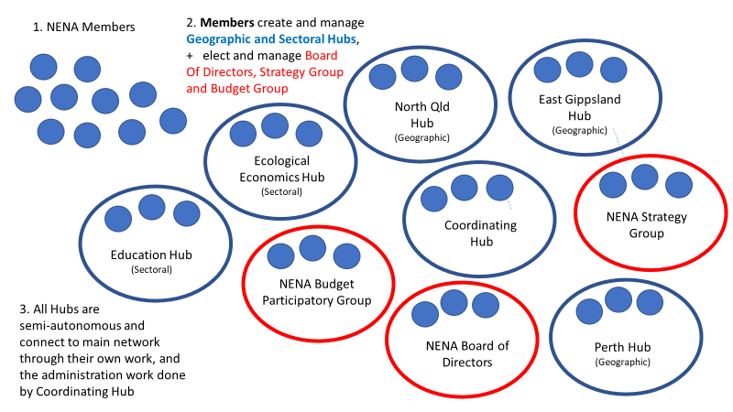
Diagram 2 – How the Network will build its Core Strategies: the Strategy Group
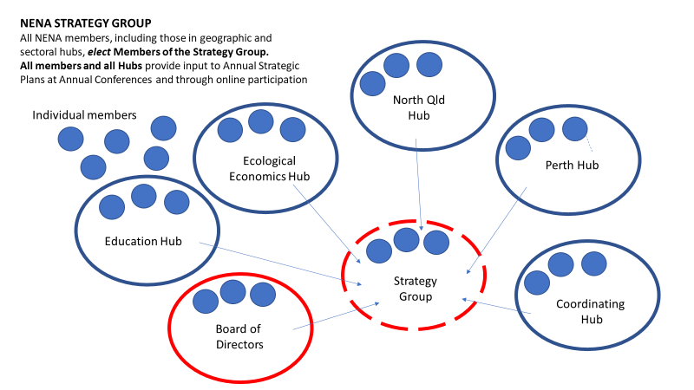

Diagram 3 – How the Network will determine financial structures and priorities: the Budget Participatory Group
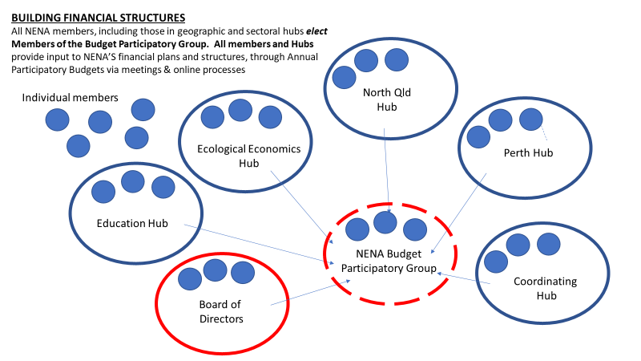

Diagram 4 – How the Network will ensure good governance, legal compliance and business management
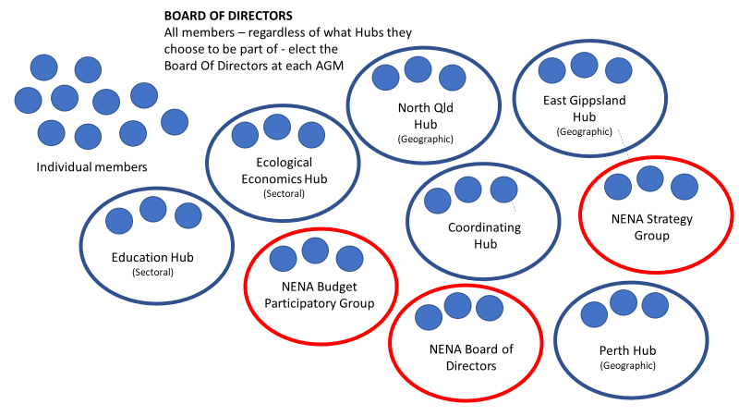

NENA Geographic and Sectoral Hubs
To carry out our work, NENA is made up of a growing number of connected, semi-autonomous Sectoral and Geographic Hubs that bring people together to focus on different issues in the new economy. NENA also has a central coordinating hub that provides support to our Hubs across Australia, and secretariat support to our elected groups.
Our Hubs reflect the three dimensions to NENA’s work: we are building networks, connections and shared initiatives:
- within specific geographic areas such as towns/cities, regions and states.
Please read about our Geographic Hubs for more information
- across different sectors within the new economy, including: sustainable food, energy, transport, housing, indigenous economics, ecological economics and many more. Please read about our Sectoral Hubs for more information.
- that prioritise specific strategic goals every year. Information about NENA’s Annual Strategic Plan will be available soon; the Coordinating Hub will ensure all Hubs have processes to contribute to NENA’s Strategies and Plans.

NENA Coordinating Hub

Until funding is obtained for paid staff, volunteers are managing all aspects of NENA’s work. Volunteers have offered to manage the NENA Coordinating Hub. The Coordinating Hub will provide the following support:
- Coordination support, including answering emails and linking people to existing hubs or helping them create their own new hubs
- Social media, website and other internal communication support for members
- Social media, website, communication and coordination support to the NENA Hubs
- Assistance and support for NENA Hubs hosting conferences, symposia and other events
- Secretariat support for the NENA Board of Management, NENA Strategy Group and NENA Participatory Budget Group

Communicating together, within the NENA network

Communicating effectively between all elements of the network is critical for the long term success of NENA.

NENA Communication Objectives
- To make communication networks work across the organization.
- To ensure that all information is communicated/transferred
- Operational processes
- Current issues and priorities
- Future plans and strategies
- Financial information
- To identify ‘best uses’ for the various forms of communication technologies/platforms available so that they will be effective in/at the various ‘work situations/levels’ of NENA.
- To transfer to people the information that they need to rapidly and successfully participate in achieving local objectives - preferably via peer-to-peer networks/platforms.
- For organization-wide objectives, to assess and plan effective ‘messaging’ when ‘up, down, and across’ members are all present (eg: at annual meetings)
- To frame all messages with the intent to create an open and responsive communication environment

Supporting members to engage in NENA communication pathways

NENA’s Membership Pack will include information for members to find and communicate with each other. It will include:
- Acceptance form and signing up to NENA membership policy.
- Acknowledgement of personal responsibility in becoming informed - and keeping informed - of NENA’s activities through joining NENA’s general/public communications channels (eg: facebook, twitter etc).
- Directions on how and where to participate in Hub work via the NENA web-site and local platforms and that education on particular aspects of NENA’s work is very much self-paced, self-directed and DIY
- Key, relevant contact points/help-desks for questions and answers and peer-to-peer work at the local level.

Face to face meetings
NENA’s members will aim to meet in person as often as possible, including through
- Annual Conferences
- Regional events and gatherings
- Social nights, film nights and Retreats

Technology for virtual meetings
NENA’s zoom account will be used for
- Monthly webinars for the network, hosted by the Coordinating Team
- Regular meetings of NENA Hubs, as requested by the Hubs
- Regular meetings for the Council, Board and Participatory Budget Group

Communicating about NENA to the outside world

Shared resources to promote NENA

NENA members are invited to work together, either through the NENA Coordinating Hub or a different Hub, to ensure up to date materials are available for all members to communicate about NENA to outside networks, including: powerpoint presentations, posters, flyers and other written and video material.

External communication strategies
NENA will seek an experienced volunteer to act as a “communications/social media” expert to ensure sound and timely communications of all relevant material across the organization, and to be the ‘connector’ for material/reports to be circulated throughout the network.

ATTACHMENT 1 – MEMBERSHIP POLICY

NENA is a growing network of individuals and organisations working to transform Australia’s economic system. We are working towards ensuring ecological health and social justice are the foundational principles and primary objectives of the economic system. By becoming member of NENA yourself, or with your organisation, you will be actively contributing to progressing NENA’s vision and making tangible the new economy, one premised on the wellbeing of planet and people.

Criteria for Membership
NENA membership is open to individuals and organisations in Australia who share, and agree to, NENA’s mission, principles and objectives, are willing to adhere to membership policies, and consent to be publicly listed as NENA members.

Membership Benefits
- Have your organisation or community listed on our directory and national map. As a member of NENA you, or your organisation or initiative will be listed on our website – an easy to find and navigate directory of all the activities and organisations supporting momentum towards the new economy.
- Discounted tickets for our annual conference (from 2019 onwards). NENA’s conference is one of Australia’s largest gatherings of a broad sector of organisations working towards a fairer and more ecologically restorative economy. Join us to share stories of success, address challenges and unite with the broader movement.
- Connection, learning and networking with peers involved in similar essential work in the new economy. As a member this can be done through a NENA hub, event or webinar.
- The ability to join or start a hub. Hubs are sectoral or locality-based clusters of organisations and/or individuals working on specific topics, themes or initiatives within the network. They serve to connect, deepen learning and development opportunities and identify common issues across the sector. They can also be used to establish a community platform for a region that is seeking to grow and strengthen their local economy. These hubs converse and
- interact with NENA’s Strategy Group, and feed into deciding and advancing the overarching objectives of the network.
- Ability and resources to organise and host a NENA event. Create a conversation in your community about issues challenging our economic and planetary well-being. Membership will allow you to host people under the NENA banner, though a film night, symposium or community forum, to have meaningful discussions about key issues in the network. It will also grant you access to a communications pack, with NENA logos, PowerPoint presentations and key talking points.
- Vote for office holders or stand for elections yourself for NENA’s Board, Strategy Group and Budget Group. NENA aims to be as participatory as possible in its governance structure, allowing for a range of ways to be involved.
- Connect to international networks and organisations, such as RIPESS and the Wellbeing Economy Alliance.
- Be invited to contribute to NENA-wide submissions to government on matters relevant to NENA’s guiding objectives.

Membership fees are offered on sliding scale from individual to organisations dependent on total income. Please see details below.

Cost of Membership – 2018-2020
- Individual membership – $30
- Organisational membership – sliding scale based on annual net income:
Organisation income | NENA annual membership fee
0-$5,000 | $50 per year
$5,000-$20,000 | $100 per year
$20,000 - $50,000 | $150 per year
$50,000 - $200,000 | $300 per year
Over $200,000 per year | $500 per year

Rights and Responsibilities of Membership
Please see the NENA Constitution for more details, but in summary:
Each NENA member is entitled one vote for the NENA Board of Directors, one vote for members of the NENA Strategy Group and one vote for the NENA Participatory Budget Group.
Members are invited to consider joining NENA Hubs, and creating or joining existing NENA Chapters in towns, cities and communities.

Denial or Termination of Membership
The NENA Constitution sets out all provisions relating to the acceptance and termination of members.
Membership can be terminated if a member breaches the Code of Conduct.
Conflict management and resolution processes are set out in NENA’s Constitution.

