The Great Environment/ Economy Survey and the Dec 7th ‘Dialogue for a Sustainable Economy’ event in Sydney
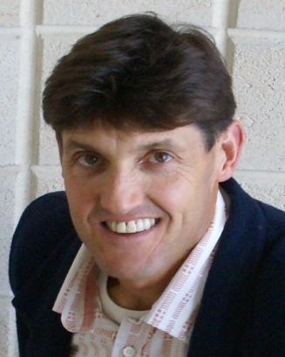
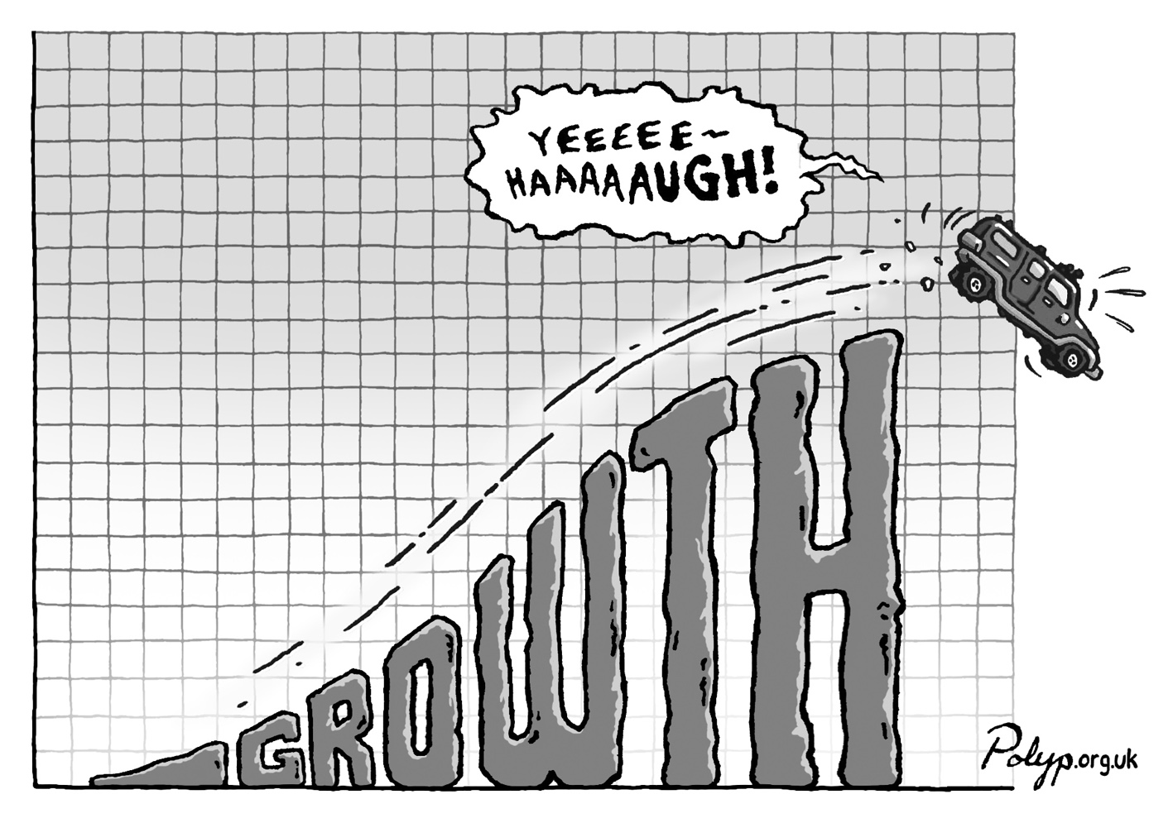
CASSE NSW and NENA would like to invite you to fill in the Great Environment/Economy survey at https://www.surveymonkey.com/r/DRRLJTG

We also invite you to the ‘Dialogue for a Sustainable Economy’ event
When: Dec 7th, 10 to 4
Where: Sydney Mechanic School of Arts (280 Pitt Street)
Program: Talk by ecological economist A/Prof Philip Lawn on ‘What would a truly sustainable economy be - living in a finite world?’, followed by a panel discussion on ‘Finding hope – change for a sustainable economy’, plus workshops on finding solutions.
Book on https://www.trybooking.com/BFQSV (or tickets at the door $10)

