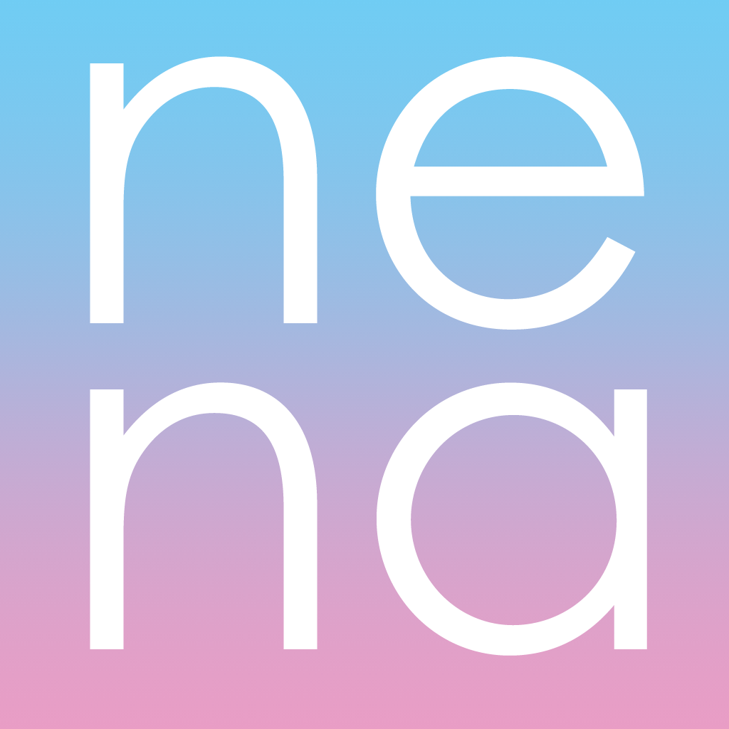 | New Economy Network of Australia  PO Box 405, Banyo 4014  www.neweconomy.org.au  nena@neweconomy.org.au

VOLUNTEER APPLICATION

This application form is for students and professionals who would like to volunteer directly with NENA. If you are a university student seeking a university based placement or internship with NENA, please email a request to: nena@neweconomy.org.au outlining your area of interest, and the requirements of your university.

Once you have completed this form, please email it, together with your resume and any other relevant information, to: nena@neweconomy.org.au

PERSONAL DETAILS (PLEASE PRINT)

NAME: PREFERRED NAME (if different):

MALE ☐ FEMALE ☐ OTHER ☐ (Please self-identify as appropriate)

ADDRESS:

If you’ve provided a PO Box, please tell us the Town/City you’re based in:

PHONE: EMAIL:

APPLICATION INFORMATION

1. How did you hear about volunteering with NENA?

NENA event ☐ NENA website ☐ Friend/contact ☐ Other ☐ (please give details below)

2. Which areas of NENA’s work would you like to get involved with?

3. What type of volunteer work are you interested in?

Research ☐ Event Management ☐ Advocacy ☐ Hub Support ☐
Communications ☐ Social Media ☐ Admin ☐ Other ☐ (please give details)

4. What particular interests, skills and/or abilities could you share with us?

5. Do you have relevant qualifications (or current study)?

6. Do you have relevant experience from previous paid or voluntary work?

7. Why do you want to work with us?

8. What days/times are you available?

9. Is there any other information that you would like to provide?

Please attach your resume and provide contact details for two referees who are able to comment on your skills, abilities and suitability for this role.

Referee 1 Referee 2

Name: Name:

Phone: Phone:

Email: Email:

I confirm that the information I have provided above is truthful and accurate.

Signed: Dated:

