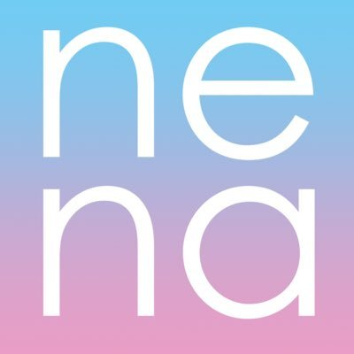 | New Economy Network Australia  NENA Board of Directors - Nomination Form
Nominee Details:
Name:
Address:
Email address:
Mobile:
I declare that I am 18 years of age or older: Yes/No
I declare I am an Individual Member: Yes/No
Or
I declare that I am an authorised representative of an Organisational Member of NENA: Yes/No
Name of Organisational Member:
I declare I am NOT a disqualified person for the purposes of s181 of the CNL: Yes/No
Nominee Capabilities:
Please provide up to 500 words describing your qualifications and experience relevant to the position of NENA Director. This statement will be used for your election campaign should we have more candidates than there are vacancies. You may also attach your CV if you wish.

Nominee Consent:
Nominee Signatory

Nominator Details:
Please provide details of two current NENA members who endorse your nomination (note this may also be provided via email)

Name of Member (1): Signature of Member:
Name of Member (2): Signature of Member:

Photo – please attach a high-resolution profile (head shot) photo that can be used on the NENA website. Your address and phone number will NOT be made public.
EMAIL YOUR NOMINATION TO: secretary@neweconomy.org.au

