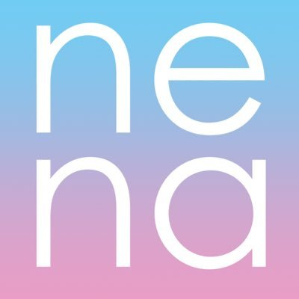 | New Economy Network Australia  NENA Participatory Budget Group (PBG) - Nomination Form
Nominee Details:
Name:
Address:
Email address:
Mobile:
I declare that I am 18 years of age or older: Yes/No
I declare I am an Individual Member: Yes/No
Or
I declare that I am an authorised representative of an Organisational Member of NENA: Yes/No
Name of Organisational Member:
Nominee Capabilities:
Please provide up to 500 words describing your qualifications and experience relevant to the position of Member of Participatory Budget Group (please refer to relevant Position Description for). You may also attach your CV if you wish.

Nominee Consent:
Nominee Signatory

Nominator Details:
Please provide details of two current NENA members who endorse your nomination (note this may also be provided via email)

Name of Member (1): Signature of Member:
Name of Member (2): Signature of Member:

EMAIL YOUR NOMINATION TO: nena@neweconomy.org.au

